# 384-386 Request: delete “mapunit_hel_class”, “mapunit_hel_class_water”, “mapunit_hel_class_wind” from the “data_mapunit” table. Do I delete the mapunit_hel_class etc from mapunit in SSURGO too?

## Delete the table column. (Mark for deletion. Upload changes). Add note in System Table History

### 

## Delete the attribute (Mark for deletion. Upload changes. Make sure that the table column is already deleted)

### 

## Do that for all the systems (NASIS, Pedon PC, Soil Data Mart, Soil Data Warehouse, Staging Server, SSURGO) Not in pedonPC, under mapunit for Soil Data Mart and SSURGO.

### 

## Delete domain (if you can) (Should I delete mapunit_hel_class domain in my tutorial? It’s not linked to anything)

### 

# 382 Request: Delete “mapunit_status_historical” attribute and “mapunit_status_historical” table column from “legend_mapunit_history” system table and the “mapunit_history” system table

## Delete “mapunit_status_historical” table column from “legend_mapunit_history” system table. Delete “mapunit_status_historical” table column from “mapunit_history”. Upload changes. Add note in System Table History: mapunit_status_historical: deleted for tutorial.

1. 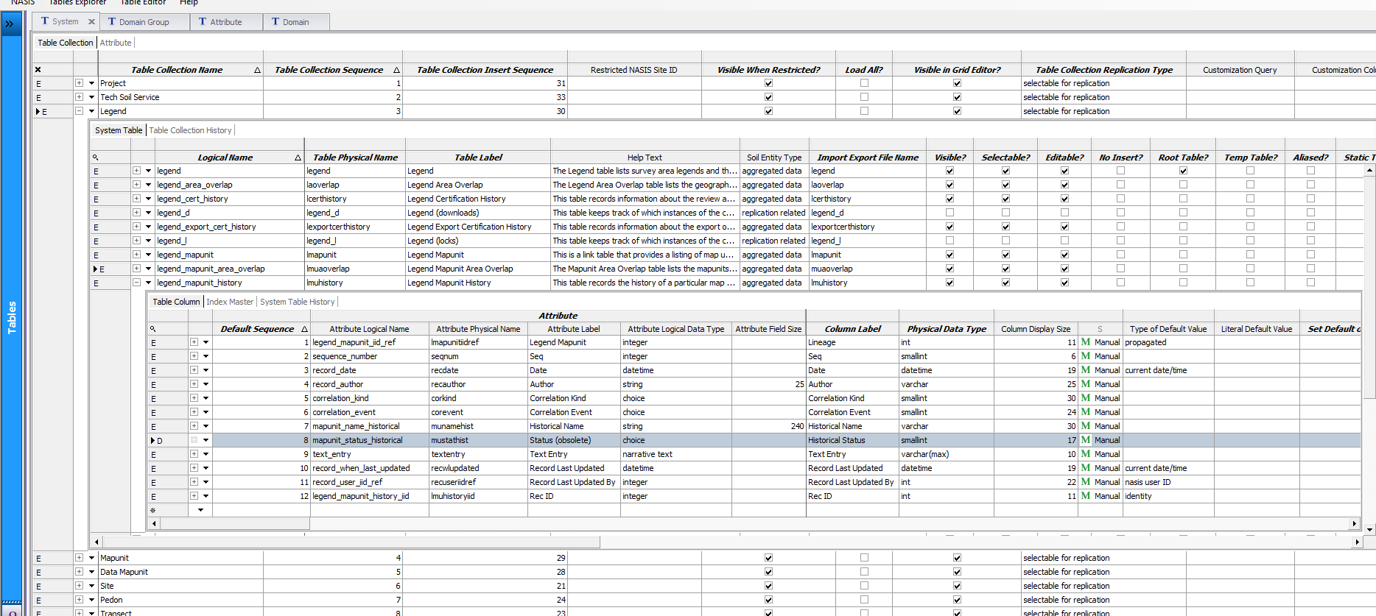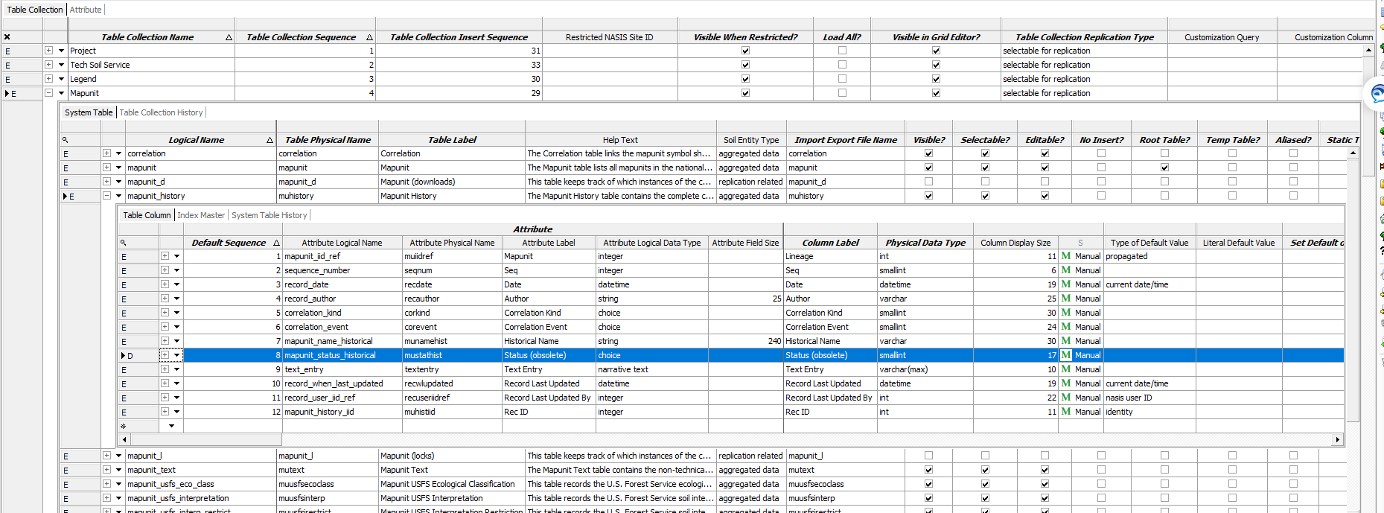

## Select “mapunit_status_historical”. Click “find related for selected rows”. Select “Table Column”. Make sure nothing is tied to that attribute. Delete.

### 

## Do this for all systems. Not in Pedon PC. Not in Soil Data Mart. No “legend_mapunit_history” system table in Soil Data Warehouse or Staging Server

# 383: Delete windbreak_suitability_group from component table. Add text note in System Table History. Upload changes.

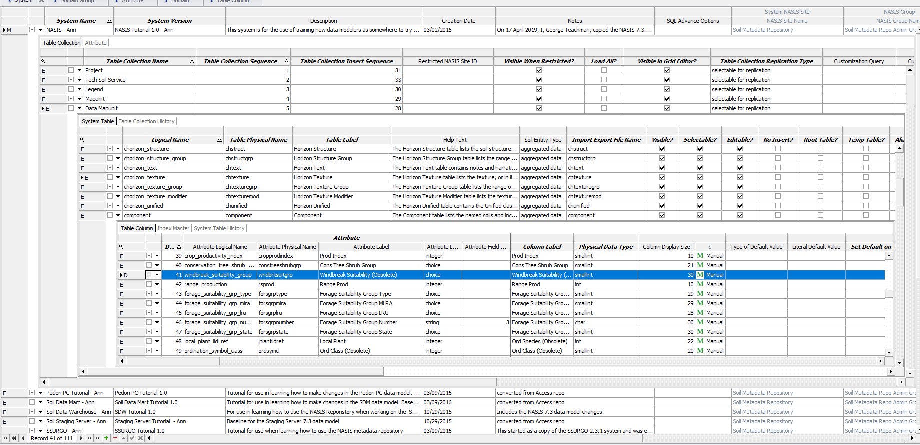

# 381 and 336: Delete mottle_locations from phorizon_mottles. Do the same, only need it for NASIS and Pedon PC.

# 380: Delete sir_number from Component. 374-375 Delete “sir_layer_id_number” domain, delete “sir_layer_id_number” from chorizon table NASIS, SDW, Staging Server

## 

# 375-379 Delete “ordination_symbol_class” and “ordination_symbol_group” and “ordination_symbol_subclass” from component

## Delete in table collection. Write a text note in System Table History. Upload changes.

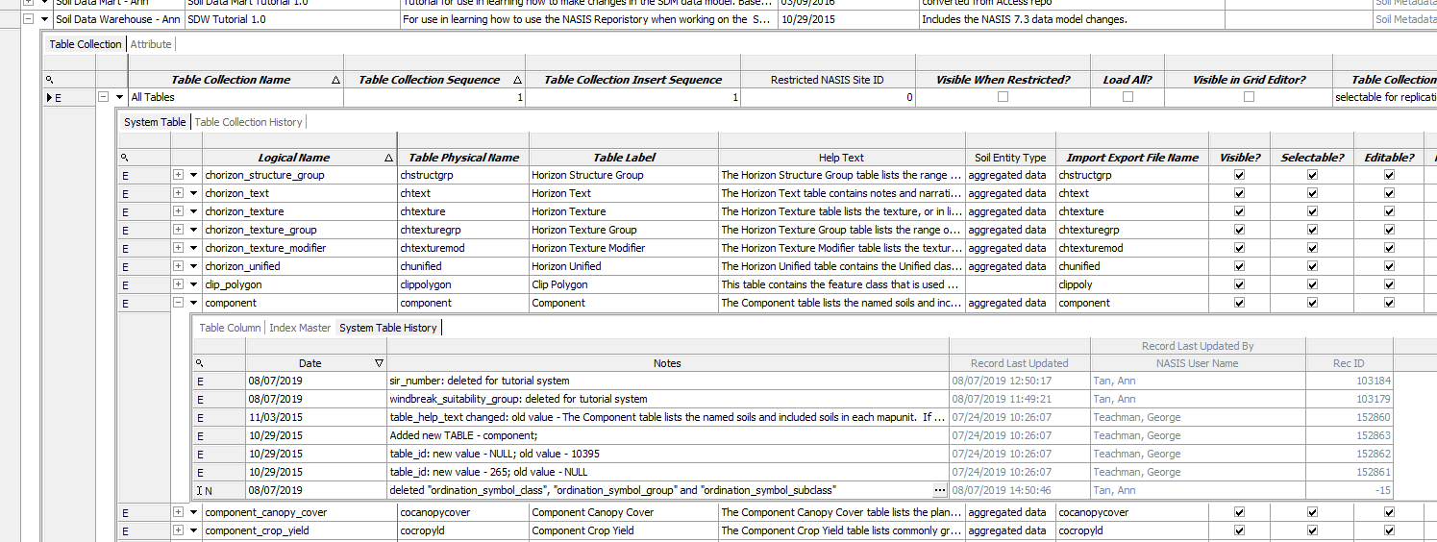

## Delete in attribute

### 

## Do that for Soil Data Warehouse (not in Pedon PC or Soil Data Mart) and Staging server

# 377 Request: Delete column “local_plant_iid_ref” aka column label: Ord Species (Obsolete) from component **Need help with this

## 

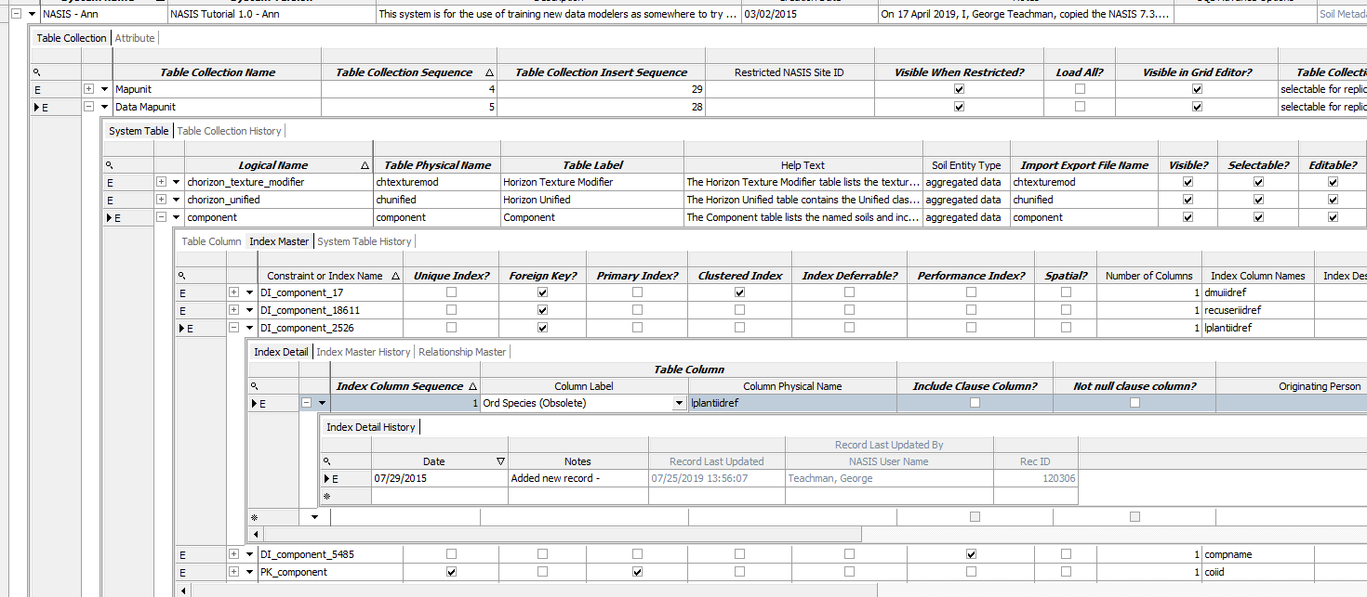

# Delete ordination_symbol_subclass domain

## 

# 371-372 Request: delete class_determining_phase from component and distribution_comp_metadata

Distribution_comp_metadata doesn’t exist in Soil Data Mart or Soil Staging Server or SSURGO

### 

# 366-370 Request: deleted woodland_equipment_rating, woodland_erosion_rating, woodland_plant_competition, woodland_seedling_mortality, woodland_windthrow_hazard from component

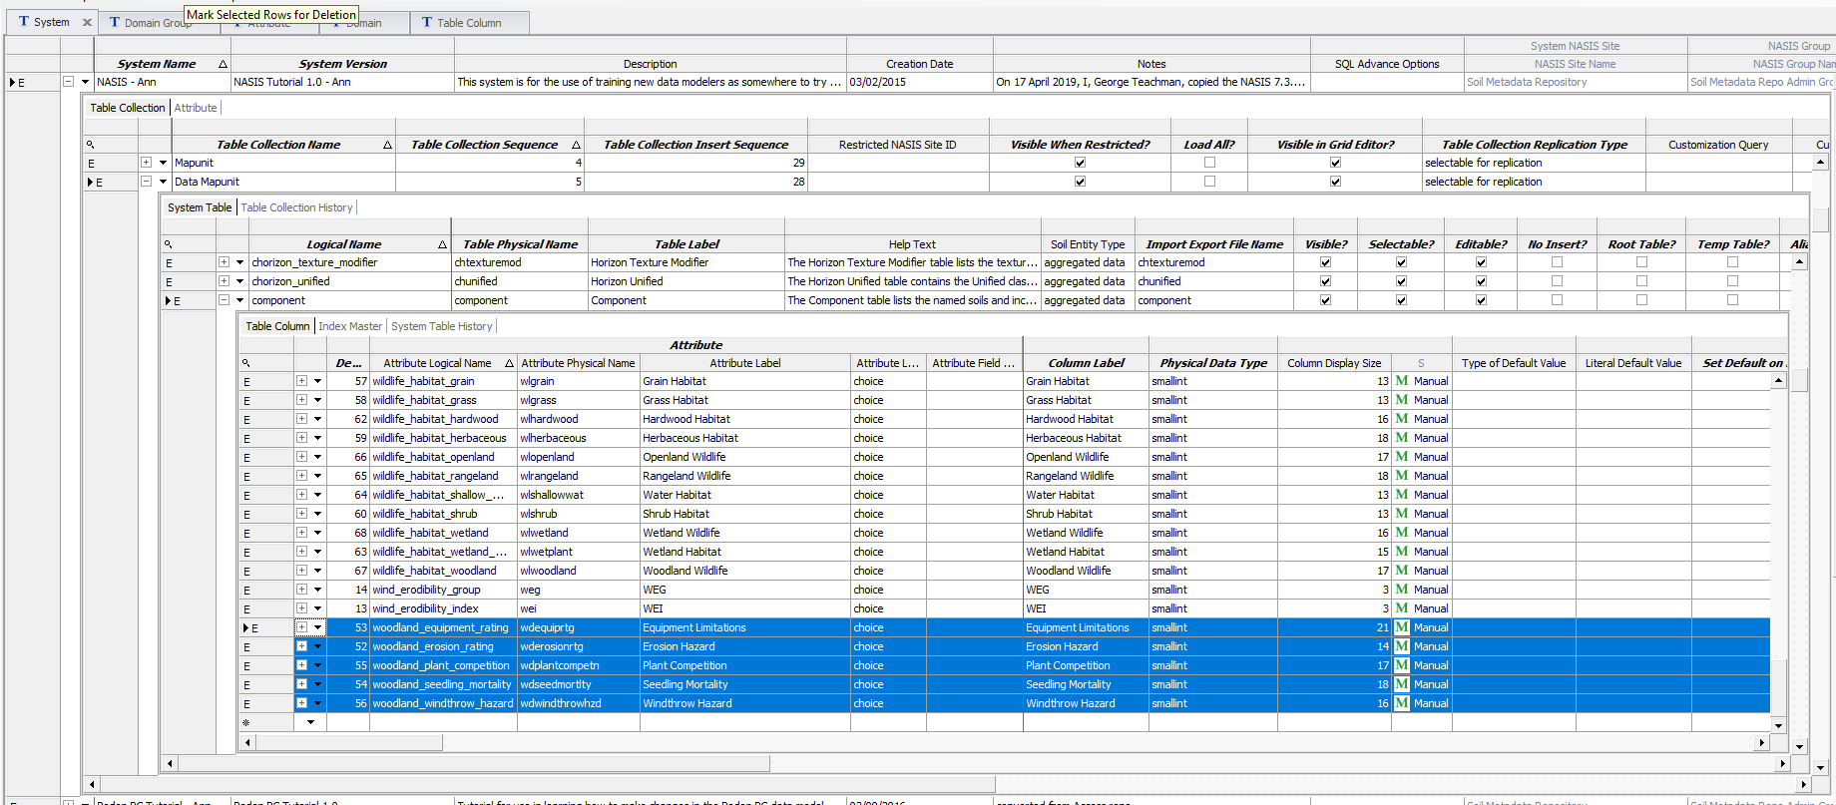

Not in pedon pc, or soil data mart, or SSURGO

# 354-365 Delete wildlife_habitat_coniferous, wildlife_habitat_grain, wildlife_habitat_grass, wildlife_habitat_hardwood, wildlife_habitat_herbaceous, wildlife_habitat_openland, wildlife_habitat_rangeland, wildlife_habitat_shallow_water, wildlife_habitat_shrub, wildlife_habitat_wetland, wildlife_habitat_wetland_plant, wildlife_habitat_woodland,

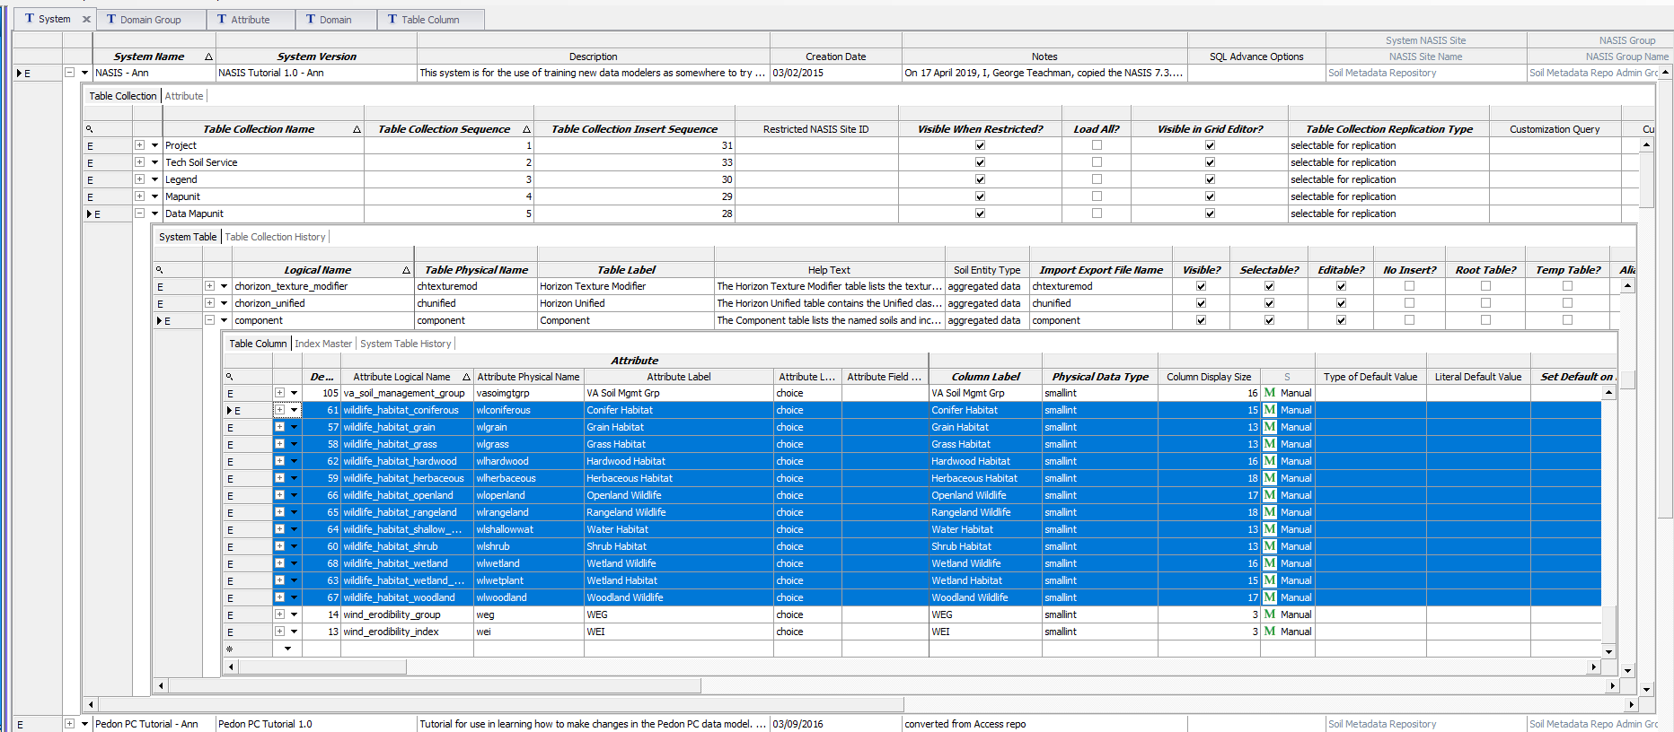

Did it in soil data mart, soil data warehouse, SSURGO, staging server

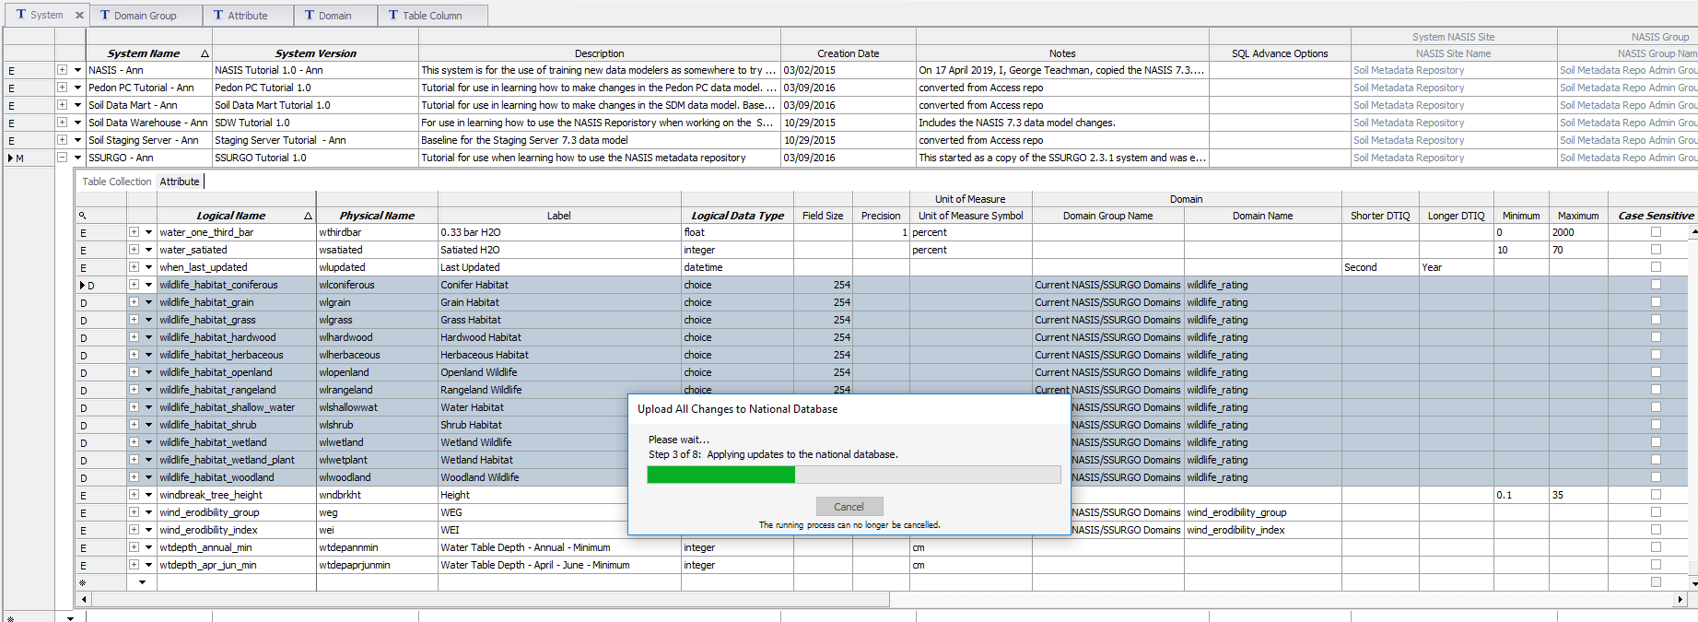

# 347-351: Delete forage_suitability_grp_lru, forage_suitability_grp_mlra, forage_suitabilituy_grp_state, forage_suitability_grp_typ, forage_suitability_grp_num from component table.

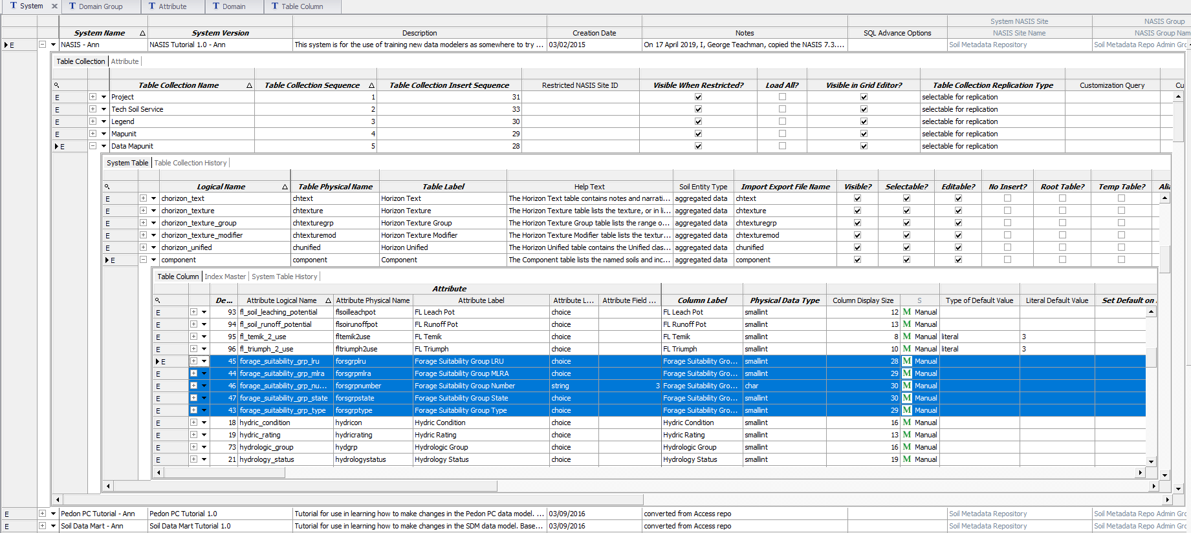

# 352-353: Delete forage_suitability_grp_id_dcd, forage_suitability_grp_id from SDM and SSURGO component table/ SSURGO muggatt table. (so far just see id in component). Can’t find _dcd

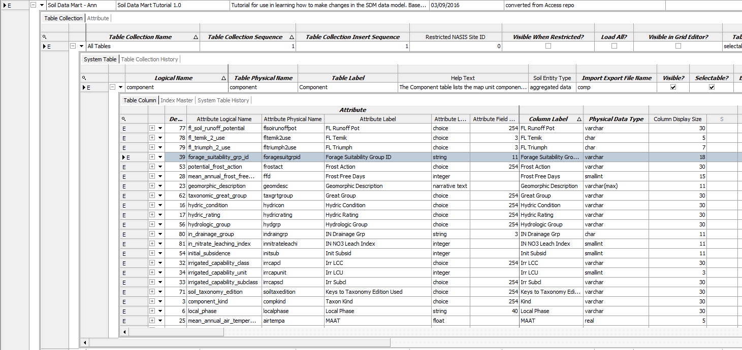

# 345-346 delete fl_highly_erodible and fl_potentially_highly_erodible from component table

# 341: delete pvsf_continuity from the phorizon_ped_void_surf_feat table: NASIS, PEDON PC -> currently referenced by column lookup record for phpvsfcolor in phor_pvsf_iid_ref

# 340 delete effervescence_location from the phorizon table NASIS, Pedon PC

## 

# 339 Request: delete site_permeability_class from site table: NASIS, PEDON PC – couldn’t find it in Pedon PC

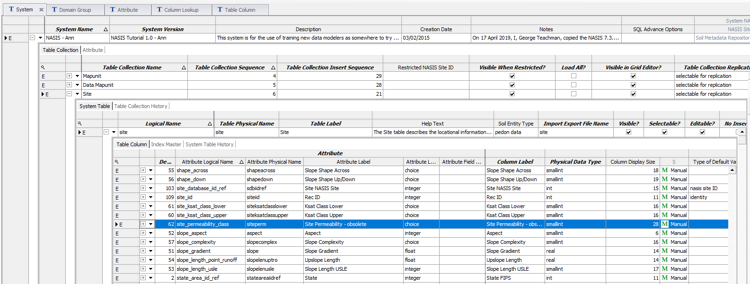

# 338 Request: parent_material_weathering from site_parent_material table for NASIS and Pedon PC

# 337: request: delete geomorph_microrelief_pattern from the site_observation table. Also delete domain.

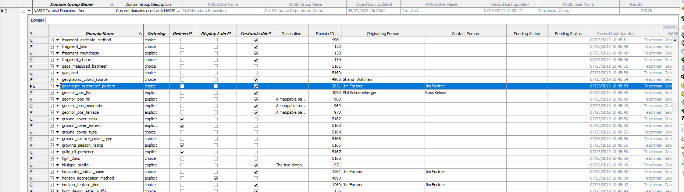

# 336 request: Delete mottle location field: NASIS, Pedon PC; domain -> already done with request 381

# 335: make “Horizon Thickness Status” field use for if the “Horizon Thickness” is calculated, prior entry, or manual entry

Do we know how to do this yet? Or should we create a new column that has “Calculatable?” checked? If we do that do we need to have a conversion?

# 333 request: collapse “Plot Tree Inventory” into “Plot Plant” inventory

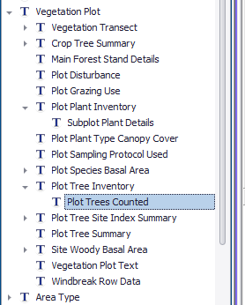

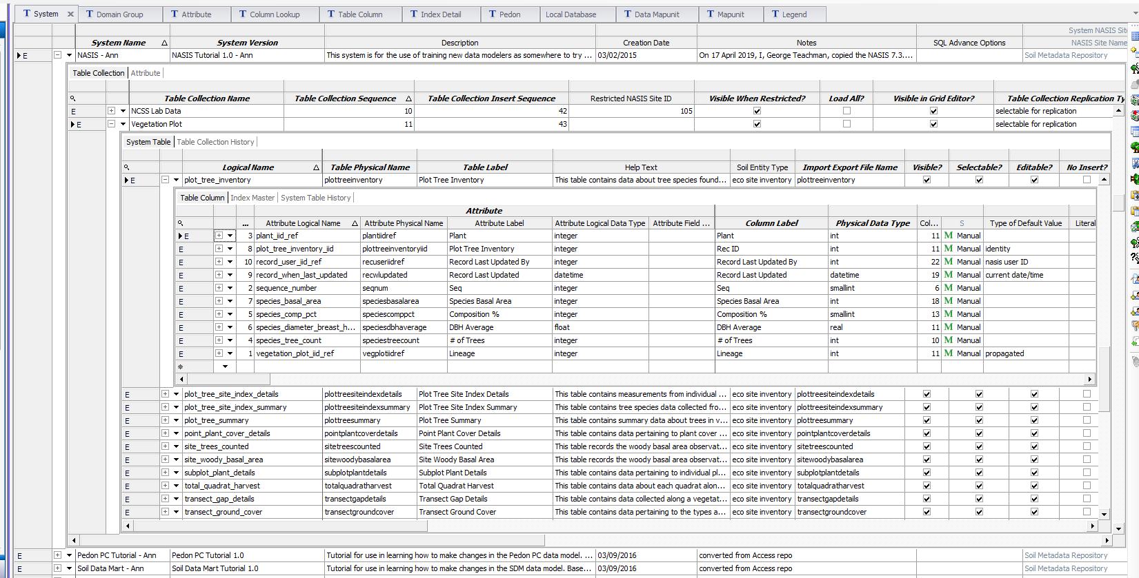

Only difference is species_comp_pct, species_diameter_breast_hit_avg, and species_tree_count

Plant_iid_ref is in a column lookup record

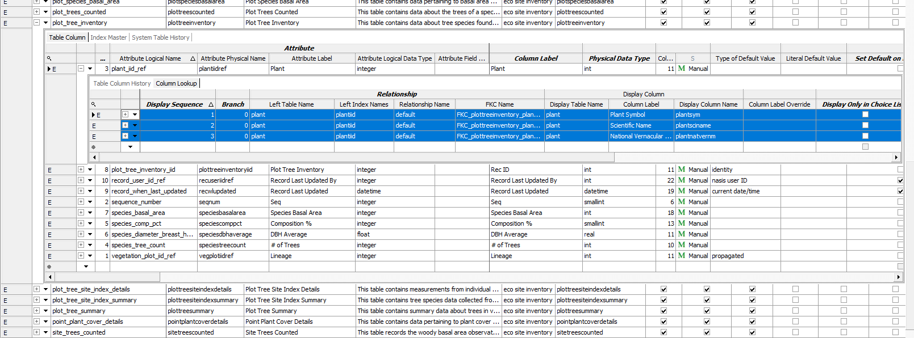

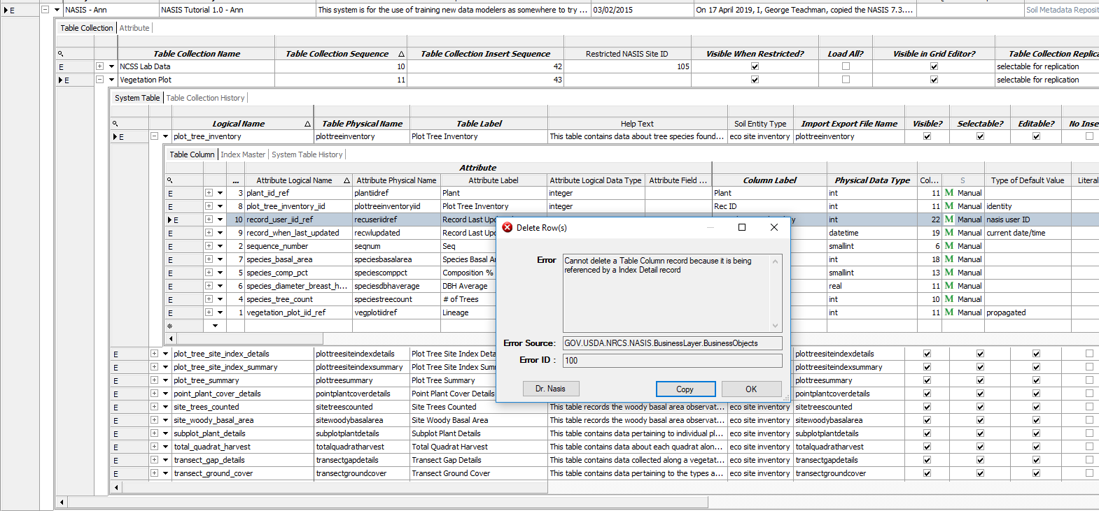

329: Add Horizon Texture that is in the Horizon Texture Group child table to the Horizon table

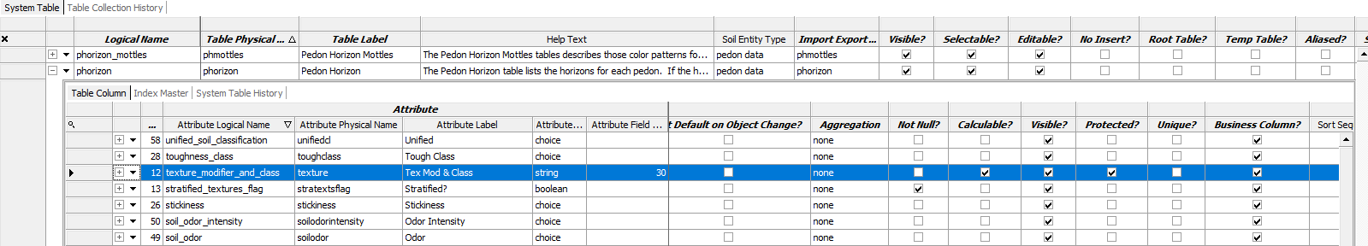

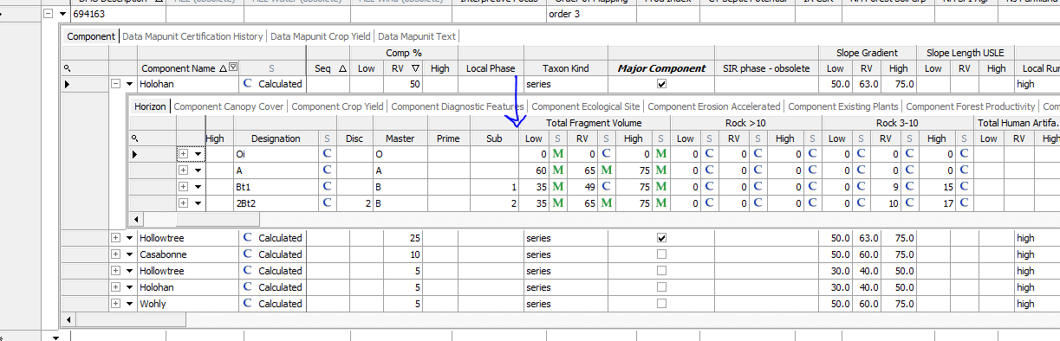

Put behind horz_desgn_vertical_subdvn, which is 10 in the default sequence

I’m using the attribute “texture_modifier_and_class”. Is that OK since it’s part of a calculation? Also there will be multiple textures to choose from. I assume we’ll have to create a calculation that shows the RV. *Check 7.4.1 to see what he did.

I checked “FGDC”. Do I need to do that if it’s just a calculation? Also, how come Oxalate Al and Excavation Difficulty moisture is not checked? Is that an oversight?

A lot of the “Sort Ascending?” and “Sort Type” is not filled out in chorizon, but I’m still able to sort in NASIS. I’m not going to fill it out for Soil Data Mart because of that. I also notice that a lot more of those are filled out in Soil Data Mart. Do we know why?

327: Do SAS pH measurements need different methods? Yes, they can use something called a YSI unit.

Added that in the ph_determination_method. Can we do that without affecting old data?

